Embedded Systems Design
20153208 Lee soyoung

PROJECT : SMART_MIRROR

What is Smart Mirror??
- A smart mirror that shows you what you want using a mirror as a display monitor
The Motivation of proposal
- Difficult to manage time while watching the mirror
What you want to implement
- Mirror is to display monitor
- The mirror show that time, date , weather ,etc…..
- We can control the mirror through voice recognition.
- Time reminder and smart phone status display via mirror
Actual production
1.Hardware Making
- Necessary article : , LCD monitor , Clear glass , Mirror film,Wood, Black tape,5mm Non-woven,tool etc….
- Attach half mirror film of same size on transparent glass of 45 * 55 size
- Remove the air bubbles between the mirror film and the transparent glass by pushing them down.
- Prepared wood is cut into 57 * 2.5 * 2.5 size and 44 * 2.5 * 2.5 size and make four each
- Use wood to make two rectangular frames.
- Put the glass with the mirror film between two frames to nail it.
- Fill the space created by the mirror with nonwoven fabric and nail on the edge of the mirror.
- Remove the bezel of the monitor with a flat screwdriver.
- Cover the bezel part of the monitor and the back of the mirror with black tape.

Image
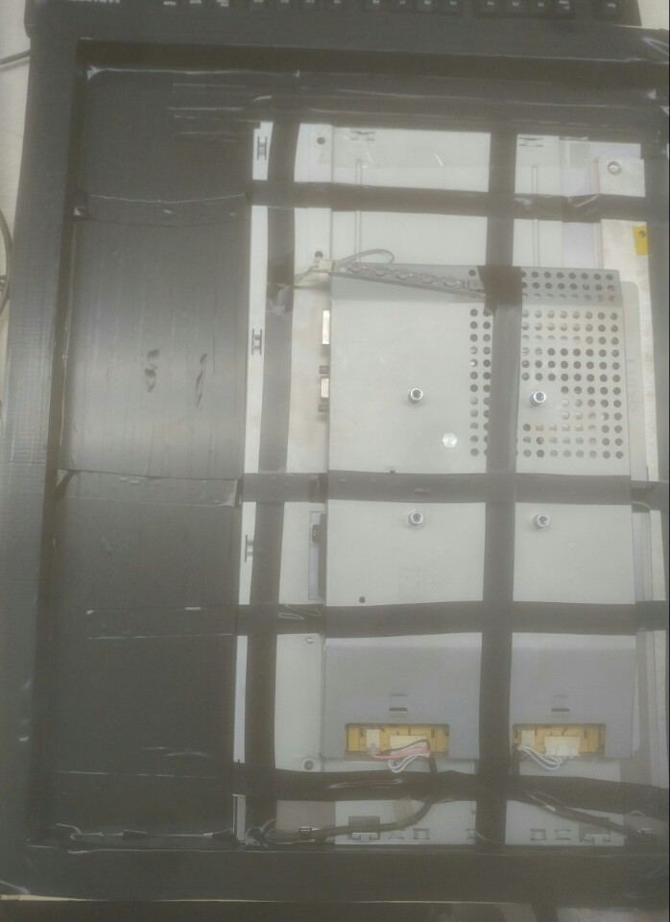
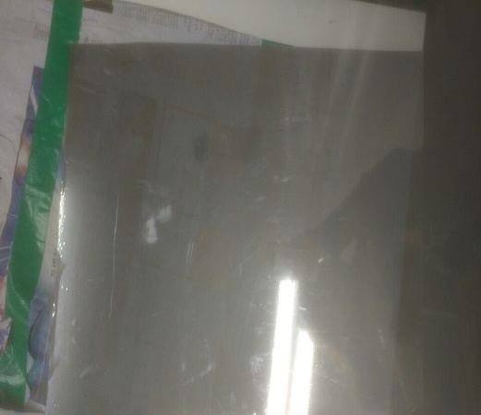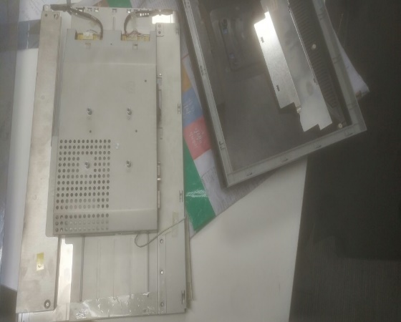
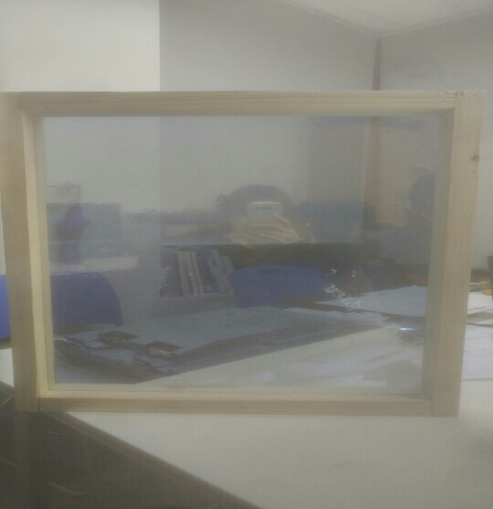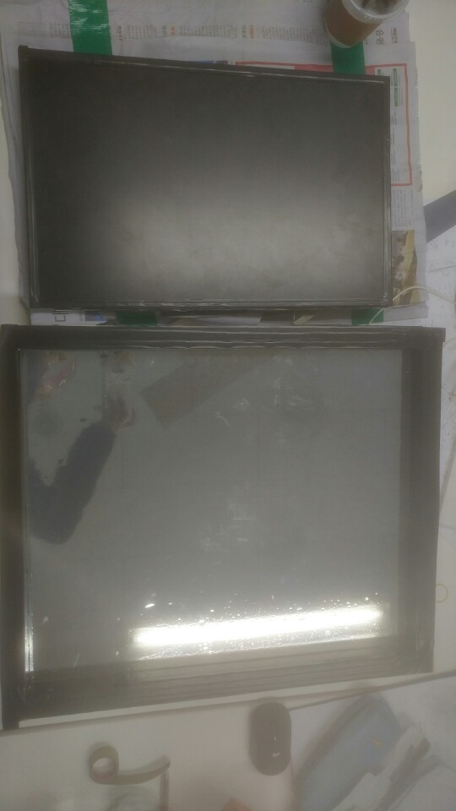

2.Software production
- Necessary article : Raspberry Pi ,LCD monitor , Speaker, Usb microphone etc…
2-1.Raspberry Pi Set
- Raspbian jessie downloads and OS seting
- Sudo rapi-config : lanquage and reqional set
- Sudo passwd root : passwd set
- Wifi set : iwconfig -> iwlist wlan0 scan -> su - -> wpa_passphrase wifi_name wifi_pw >> /etc/wpa_supplicant/wpa_supplicant.conf -> Su pi -> sudo ifup wlan0
- Korean-fonts set : sudo apt-get install ttf-unfonts-core -> sudo apt-get install ibus-hangul
- Speaker set : sudo raspi-config -> advanced Options -> 1.Force 3.5mm jack -> finish -> you can test aplay test.wav
- Microphone set : sudo vi usr/share/alsa/alsa.conf -> defaults.ctl.card 1,daefaults.pcm.card 1
- Display rotation set : sudo vi/boot/config.txt -> (bottom line) displayrotate=1
- Other setting url reference : (http://jeongchul.tistory.com/425?category=552705)
2-2. Smart Mirror Display
- Node download and set : wget https://nodejs.org/dist/v.4.0.0-linux-armv7l.tar.gz -> tar -xvf this file
- Github Opensource load : make dictory -> git clone https://github.com/evancohen/smart-mirror.git
- Node-module load : npm install
- Test-smart-mirror : cp main.js -> npm start
- Customizing open source css, html, and js using Eclipse tools
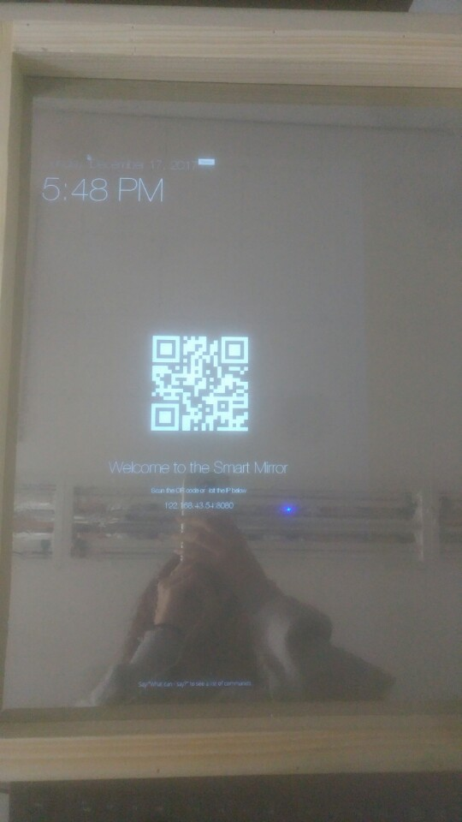
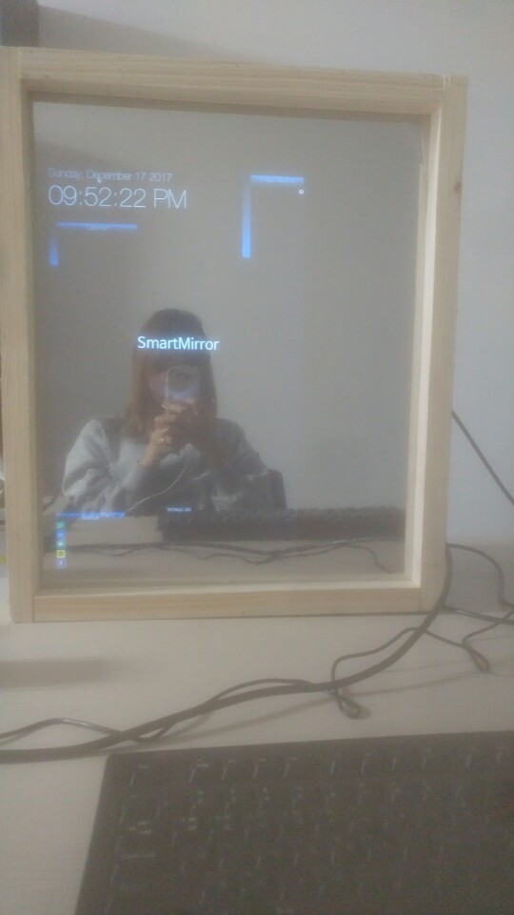
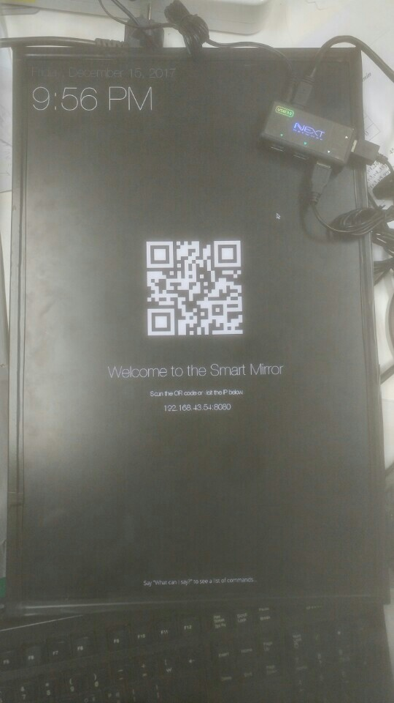
2-3. Voice recognition.
- Attempt to implement speech recognition using nodejs
- Attempt to implement speech recognition using python
- Failed to implement : I am sorry that the period is short.

